**Interesting Plant Facts**

Some plants do not have flowers or seeds, e.g. moss and ferns. They reproduce by making spores.

Some trees are deciduous and lose their leaves in the winter, while other trees are coniferous (or evergreen) and keep their leaves all year round.

Some plants live underwater - they are called aquatic plants.

**Books, stories and webpages linked to the topic:**

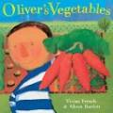 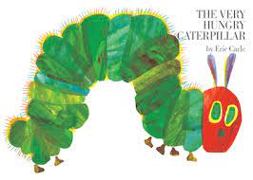

**Key Vocabulary and definitions:**

|  |  |  |
| --- | --- | --- |
| root |  | The roots anchor the plant. They absorb water and chemicals so plants can grow. |
| stem |  | The stem supports the plant and transports food. |
| trunk |  | The main stem of the tree. |
| leaf |  | The leaf makes food for the plant |
| flower |  | Some buds produce flowers which produce seeds for new plants. |
| petal |  | A coloured separate part of a flower. |
| seed |  | Part of a plant that grows into a new plant. |
| bulb |  | A thick rounded part of a plant, from which a stem will grow up and the roots will grow down. |
| germination |  | When a seed begins to grow. |
| life cycle |  | The series of changes in a living thing. |

**Home learning:**

Can you make a model of a miniature garden?

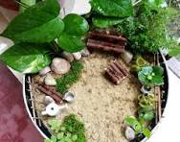

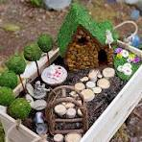

When you have completed your model, please can you bring it into school.

**Our objectives for the topic:**

I can name the parts of a plant

I know what plants, need to grow

I can describe the life cycle of a plant

I know what parts of a plant we eat

I can recognise and name wild flowers

I can describe a life cycle for a seed

I can explain what parts of the plants do

I know seeds come in different shapes and forms

**Essential Knowledge:**

We can observe the natural world and talk about what we see

We eat plants for food

We can identify and name different plants and trees

We can describe different weather patterns

We can name the seasons in the year

**Knowledge Organiser-Year R and 1-Term 4**

**Topic title:** **Oliver’s Vegetables Topic Themes: Science/ Knowledge and Understanding of the World**