Langdon Primary School – Progression in Art and Design (2019)
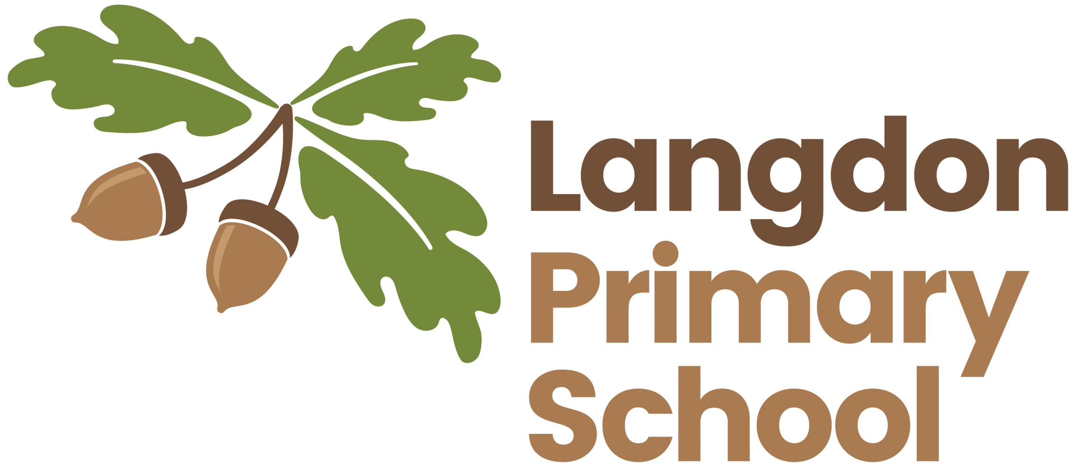
 | Year R | Years 1 and 2 | Years 3 and 4 | Years 5 and 6
Painting | - Naming colours.  - Identify primary colours.  - Explore mixing colour.  - Experiment with colours.  . | - Use thick and thin brushes appropriately.  - Mix primary colours to make secondary.  - Add whites to make tints and black to make shades.  - Create colour wheels e.g. Jackson Pollock, Kandinsky, Van Gough | - Use a number of brush techniques using thick and thin brushes to produce shapes, textures, patterns and lines.  - Mix colours effectively.  - Use watercolour paint to produce washes for backgrounds then add detail.  - Experiment with creating mood with colour  - E.g. Rothko, Kandinsky, Warhol | - Sketch (lightly) before painting to combine line and colour.  - Create a colour palette based upon colours observed in the natural or built world.  - Combine colours, tones, and tints to enhance the mood of a piece.  - Use brush techniques and the qualities of paint to create texture.  - Develop a personal style of painting, drawing upon ideas from artists e.g. Lowry, Warhol, Bansky, Mosely
Pattern  Suggested artists  Joan MIRO,  Bridget RILEY, ESCHER, Paul KLINE | - Repeating patterns.  - Irregular painting patterns  - Simple symmetry | - Awareness and discussion of patterns  - Repeating patterns  - Symmetry  - Experiments with folding, repeating, overlapping, regular and irregular patterning  - Natural and manmade patterns  - Discuss regular and irregular | - Design  - Using ICT  - Make patterns on a range of surfaces  - Symmetry  - Explore environmental and manmade patterns  - Tessellation | - Create own abstract pattern to reflect personal experiences and expression  - Create pattern for purposes
Collage | - Express their ideas in original ways.  - Simple collages.  - Simple weaving. | - Use a combination of materials that are cut, torn and glued.  - Sort and arrange materials.  - Mix materials to create texture e. Paul Klee | - Select and arrange materials for a striking effect.  - Ensure work is precise where appropriate.  - Use coiling, overlapping, tessellation, mosaic and montage e.g. Matisse, Picasso. | - Mix e.g. rough and smooth, plain and patterned  - Combine visual and tactile qualities, e.g. Escher, Matisse, Malevich.  - Use ceramic mosaic materials and techniques.
Sculpture | - Explore a variety of materials playdough, wet sand and modelling clay. | - Use a combination of shapes.  - Include lines and texture.  - Use rolled up paper, straws, paper, card and clay as materials.  - Use techniques such as rolling, cutting, moulding and carving. E.g. Andy Goldsworthy. | - Create and combine shapes to combine recognisable forms.  - Include textures that convey feelings, expression of movement e.g. Turner.  - Use clay and other mouldable materials.  - Add materials to provide interesting detail. | - Show life-like qualities and real life proportions or, if more abstract, provoke different interpretations.  - Use tools to carve and add shapes, texture and pattern.  - Combine visual and tactile qualities.  - Use frameworks (such as wire or moulds) to provide stability and form, e.g. Colder.
Drawing | - Begin to use a variety of drawing tools.  - Encourage accurate drawings of people.  - Use drawings to tell a story.  - Explore different textures. | - Extend the variety of drawing tools.  - Draw lines of different sizes and thickness.  - Colour own work neatly between the lines.  - Show pattern and texture by adding dots and lines.  - Show different tones by using coloured pencils.  - Observe and draw a landscape. | - Use different hardness of pencils to show line, tone and texture.  - Annotate sketches to explain and elaborate ideas.  - Sketch lightly (no need to use a rubber) to correct mistakes.  - Use shading to show light and shadow.  - Use hatchling and cross hatchling to show tone and texture, e.g. Joan Miro. | - U sunlight).se a variety of techniques to add interesting effects (e.g. reflections, shadows, direction of light.  - Use a choice of techniques to depict movement, perspective, shadows and reflection. Choose a style of drawing suitable for the work e.g. realistic or impressionist.  - Use lines to represent movement.
Printing | - Rubbings  - Print with a variety of objects: Natural or man made  - Print with block colours in the style of Mondrian. | - Create patterns: repeating or overlapping  - Develop impressed images  - Relief printing  - Mimic printing from the environment e.g. wallpaper | - Use layers of two or more colours  - Replicate patterns observed in the environment  - Make printing blocks e.g. coiled string glued on a wooden block  - Make precise repeating patterns e.g. Warhol/(Morris see Karen Capell) | - Build up layers of colour  - Create an accurate pattern, showing fine detail  - Screen printing  - Explore printing techniques from different artists
Textiles | - Simple weaving | - Use weaving to create a pattern  - Use plaiting  - Colour fabric  - Use basic cross stitch and back stitch | - Use dip dye techniques  - Quilt, pad and gather fabric  - Explore artists using textiles | - Choose from a range of stitching techniques
Digital Media | - Use colour box tool on Purple Mash t create images | - Use a range of tools to create different textures, lines, tones, colours and shapes. | - Create images, videos and sound recordings and explain why they are created | - Enhance digital media by editing including sound, video, animation, still image, and installations

