The Langdon Curriculum

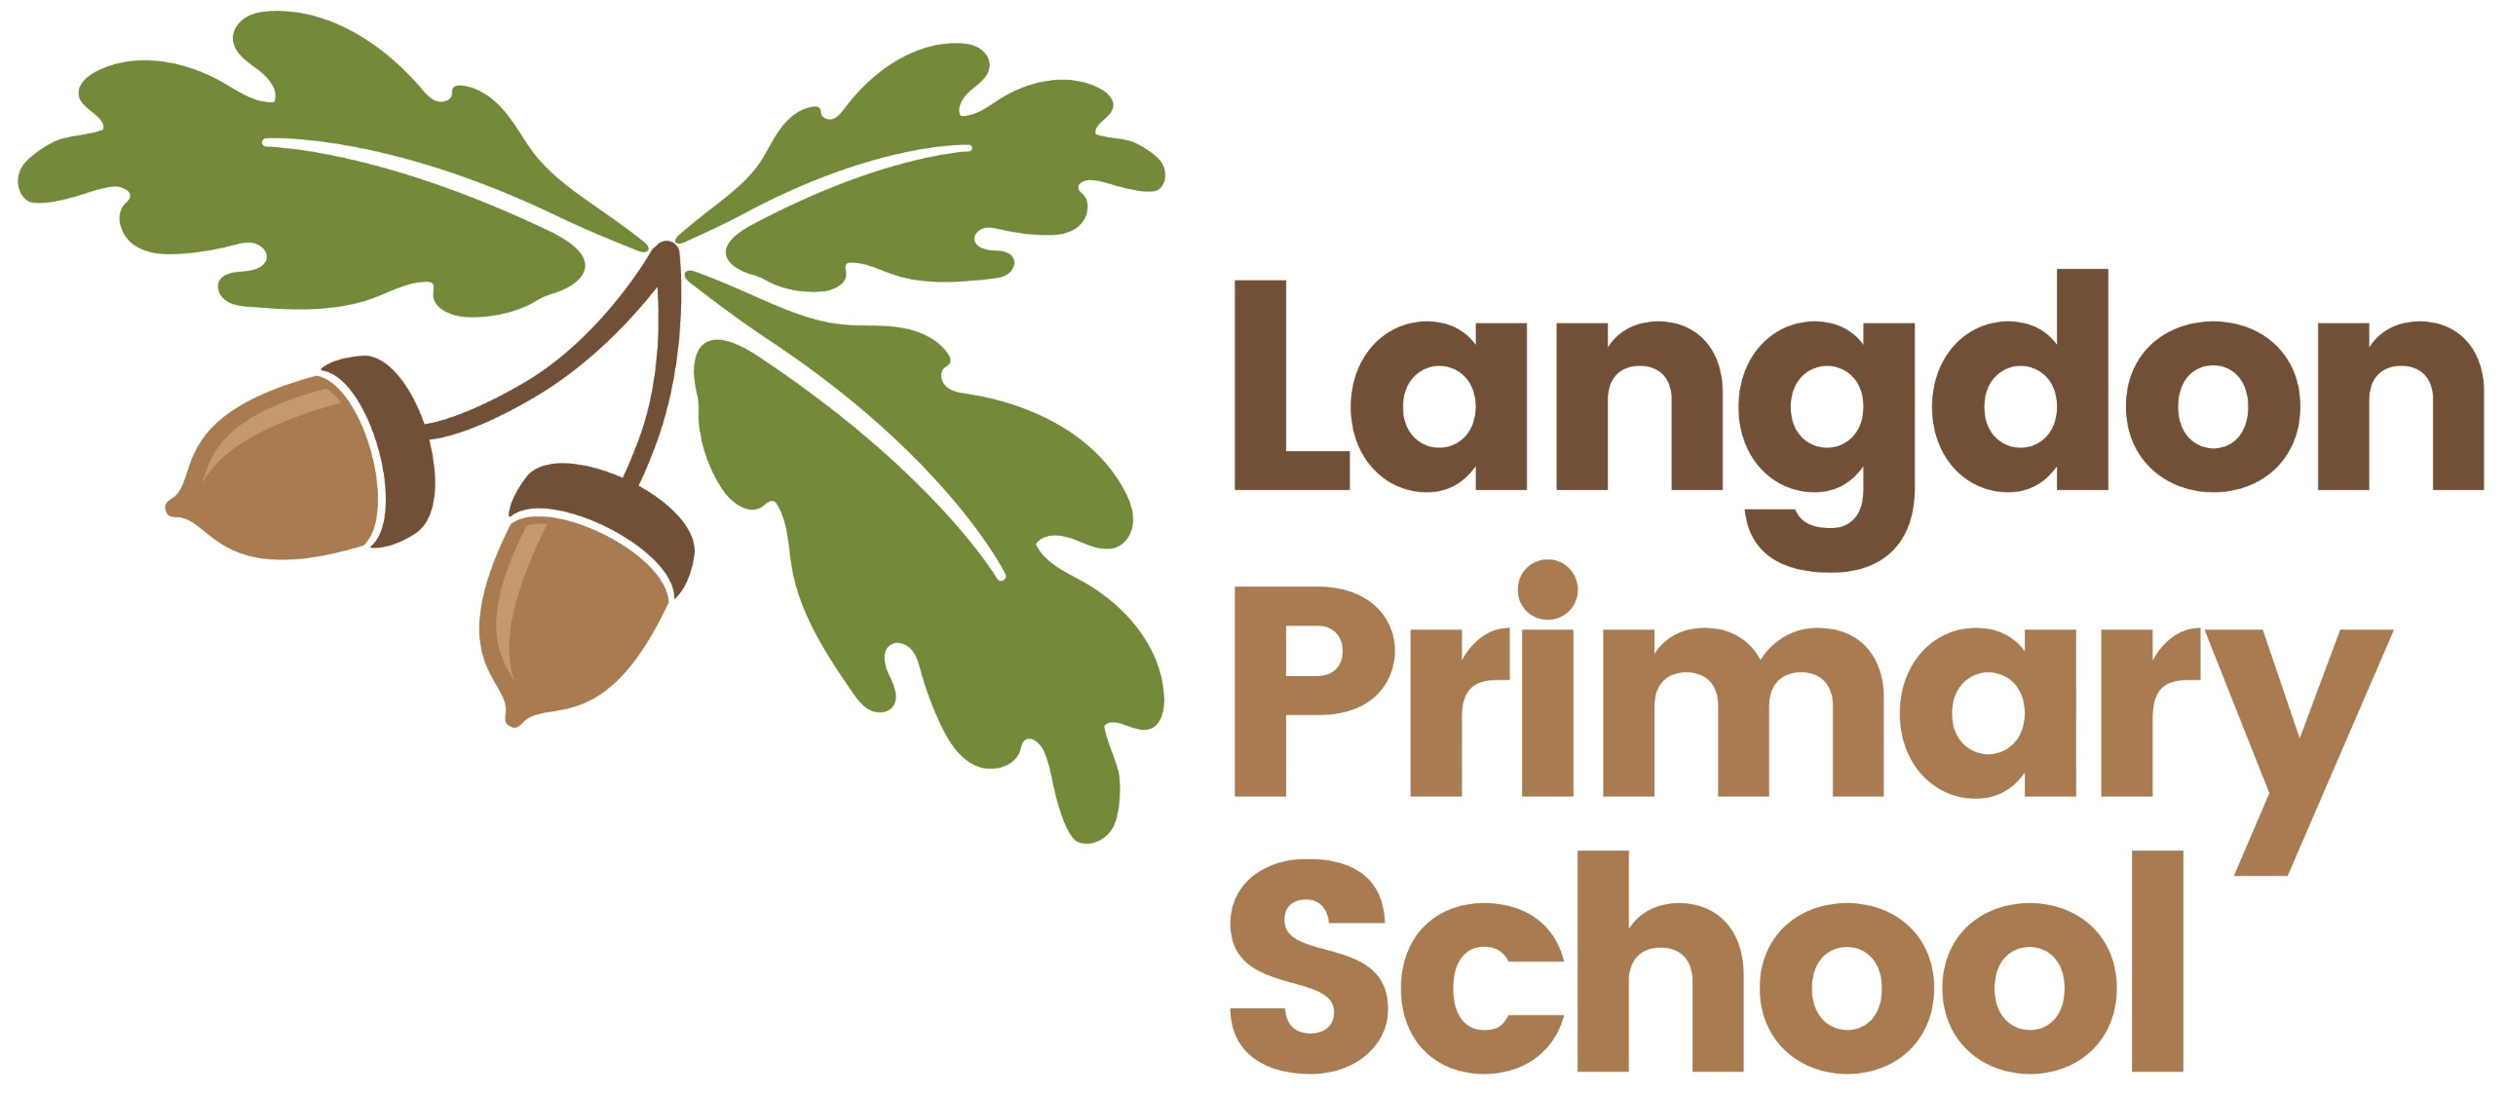
What we do:
At Langdon, we teach the statutory and some non-statutory elements of the National Curriculum as well as knowledge and skills that we believe are essential for a full, broad and rounded education.
We ensure that our learners gain knowledge in stimulating lessons and activities; that they are able to generate real and relevant links in their knowledge in order to apply it independently and that they build webs of transferrable knowledge in order to ensure deep learning in all subjects. This will include using the skills of analysis, evaluation, problem solving, creativity and independence.
At Langdon, we mainly organise our teaching of subjects through themes or topics in Integrated Learning lessons. However, some subjects are taught discretely most of the time, either because we believe they are important subjects that need a specific focus (eg. Mathematics) or because we wish to teach in meaningful linked lessons rather than make tenuous links to themes or topics. Throughout the year, we also teach subjects through themed weeks where there is a more intense focus on a subject discipline or on specific knowledge or skills.
The curriculum is enhanced with wider learning opportunities such as the use of clubs, visits, visitors and residential trips.
Pupils are encouraged to contribute to our curriculum at the planning stage for themes or topics or in ‘in the moment’ opportunities. This is so that they are able to investigate areas of interest to them and to engender their feeling of ownership over their learning. We believe that this fosters good engagement in learning.
For some pupils, we may tailor the curriculum to individual needs – either through differentiation of provision or support; through challenge opportunities or through timely intervention to address slower progress or gaps in knowledge or understanding.
We use a range of resources to teach and support the curriculum including technology, written materials, collaboration workshops, tournaments and events, visitors, outside professionals - sports coaches for example - and visits to suitable learning environments linked to the topics taught. All pupils are given homework tasks, suitable to age and/or need, in order to continue their learning at home.
Our curriculum is monitored by governors, staff, collaboration colleagues and the Local Authority in order that there is a constant focus on the quality of learning and teaching and on the impact that this has on outcomes for groups and individuals. The curriculum is not static but is constantly changing and adapting in order to meet the current needs of the learners at Langdon in order to secure high outcomes for them.

Why we do it
Our curriculum has been designed in order to promote the development of pupils’ knowledge, understanding and skills through teaching of the Early Years Foundation Stage and National Curricula and teaching that is specific and special to the context of our school.
Our curriculum aims to encourage pupils to engage in a journey of life-long learning. We ensure that pupils embark on a clear pathway of progression of knowledge and skills for each subject which is taught through high quality, stimulating teaching activities and assessed for impact. We will ensure that pupils have access to as much of the National Curriculum as possible and are able to transfer knowledge across disciplines or subjects in order to ensure deep and sustained understanding.
Our curriculum, with its focus on academic learning, practical skills and personal and social opportunities helps our pupils become well rounded individuals who are knowledgeable across subjects, who show their talents and who, at times, shine.
We aim to develop independent and confident learners who are motivated to learn, have a thirst for knowledge, are creative and resilient when needed and willing to take risks. The curriculum will help to engender high personal expectations and ambitions and this will be evident in our subject outcomes.
Our pupils learn to be sociable, caring and understanding of each other, demonstrate and develop good relationships with others and are prepared to contribute to society.
Our curriculum will be broad and balanced but we believe that some skills are important for success in future life, in learning and in the world of work. For this reason, the basic skills in reading, writing and mathematics are given priority in our curriculum. Every child will be as well prepared as possible for the next stage of their education in these subjects and these core subjects will be extensively used to support or to demonstrate learning in other subjects.
Every child will have full access to the curriculum, regardless of need. Every child matters at Langdon, and we have high expectations for them, so our pupils will be challenged to master the curriculum at their own level and will be encouraged to achieve well and attain success from individual starting points.
Subjects that we teach
These core subjects will be extensively used to support or to demonstrate learning in other subjects. They may be taught through integrated topics or discretely:
- Reading
- Writing
- Mathematics
These subjects will be taught mainly through topics where knowledge is integrated into one theme in order to allow for strong links to be made across subjects:
- History
- Geography
- Art and Design
- Design and Technology
These subjects are mainly taught discretely, although they may be included into the topics if there is a strong enough link to do so:
- Science
- Physical Education and Sport
- Religious Education
- Music
- Foreign Languages (at Langdon, our chosen language is Spanish)
Themes that we may teach subjects through:
Our integrated learning lessons allow us to teach through themes or topics. Examples of the topics we use are as follows:
- Ourselves
- Plants
- Animals
- Space
- The Stone Age
- Ancient China
- The Great Fire of London
- Florence Nightingale
- Crime and Punishment
- Antarctica
- The Rainforest
- Wild Weather
- The Environment
- Light and Colour
- Famous artists
Other additional activities to support learning:
In order to ensure that our curriculum is broad and allows for personal learning and development, we teach additional activities and lessons outside of the usual lessons in the classroom. Examples of these are:
- After school clubs
- Use of visits to other environments or places more suited to learning about a subject such as a cathedral, the seaside, a castle or a gallery
- Use of visitors who are experts in their subject
- Use of outside professionals such as coaches or music teachers eg. Dover Gym Club, Dance Extreme, peripatetic music teachers
- Residential trips – Year 2 (outdoor adventurous activities and forest school; Year 3 and 4 outdoor adventurous activities such as high and low ropes; Year 5 and 6 outdoor adventurous activities such as water sports and sailing)
- Collaboration events, workshops and tournaments

