**English (Narrative)**

Mystery/Timeslip story – set on another planet

Newspaper report on the moon landing

Balanced argument – Do aliens exist? Did man really land on the moon?

First person based Chris Hadfield’s account of living in space.

Persuasive argument – Anti gravity flight

Discussion - would you

Maths **-**

Calculating weight and ages of different planets

**PE –Dance**

Dance to the planets

**a**

**Computing**

**Internet Research –** children use the internet to gather information on space timeline and moon landing

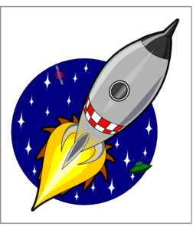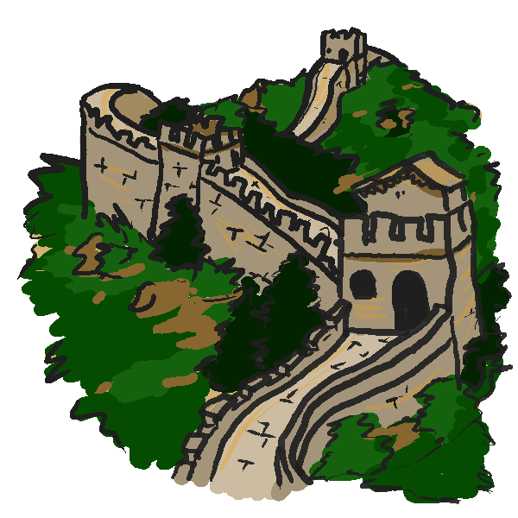

**Space**

7 weeks

November 2018/19

**Science**

Creating a mobile, showing the movements of the earth moon and sun

Create a new planet thinking about its position the solar system and how this would impact on its temperatures

Learning why we have day and night and season.

Create a moon phase 6 side opener

Trialling food and drink from space.

Learning about space junk and its impact on earth

What is the ISS?

**Geography**

locating the 10 biggest meteor impacts on a world map

**History –**

The history of space travel timeline, children decide the key events from 10-15

Writing a recount of the moon landing.

**Art**

Designing new planets

Creating galaxy pictures

**DT Designing** a balloon propelled rocket

**Music - Ukele MP**

Discussion - would you move to another planet? What rules would you have to have when starting a new colony?