**Maths**

Comparing snowfall in the UK and Scandinavian countries

**English (Narrative)**

**Not Linked to Topic**

**Literacy Shed – Alma**

**PE – Dance/ Athletics**

**Computing**

Research using google

To identify the countries of Scandinavia

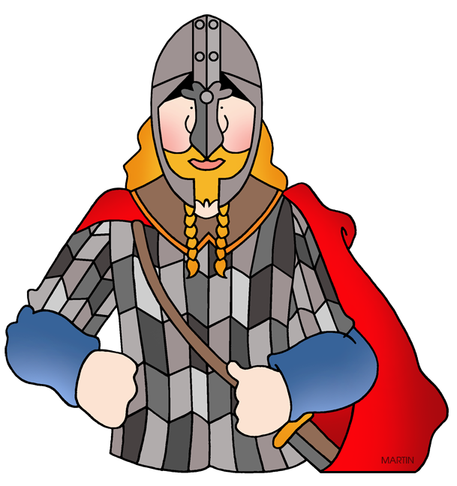

**Scandinavia/ production**

Term 6 17/18

**Geography –**

To know how countries are different or similar to our own – looking at the land of the midnight sun

Locating the countries that make up Scandinavia using a range of sources

Look at how the climate is different to our own and how they cope during winters

Looking at the Northern Lights

**Science-**

**Kent Scheme – materials and their properties**

**History –**

**Vikings and England during the Viking period**

**British Values –**

**Music – Production songs**

**VISIT –**

Art – Creating Northern lights pictures