**Maths -**

Population – plotting line graphs of China’s population

Money- Costing a trip to China

Costing an order in a Chinese restaurant

**English (Narrative)**

**Flashback Story – set in Shang Dynasty**

Written from 3rd person starting at the problem in the and using a flashback to resolve

Using twists to hook the reader and posing questions to the story opening

**Non chorological – reports**

**Dragons** – Thinking about the structure and features of reports at year 5/6 and organising paragraphs using sentence sign posts and generalising vocabulary

**PE -Na**

**Computing**

**Internet Research –** children use the internet to gather information on Shang dynasty accuracy – checking facts etc.

**Multimedia –** Produce PowerPoint presentations on Mandela’s life – showing information gathered and presentational skills. Include text, images and sound for effect.

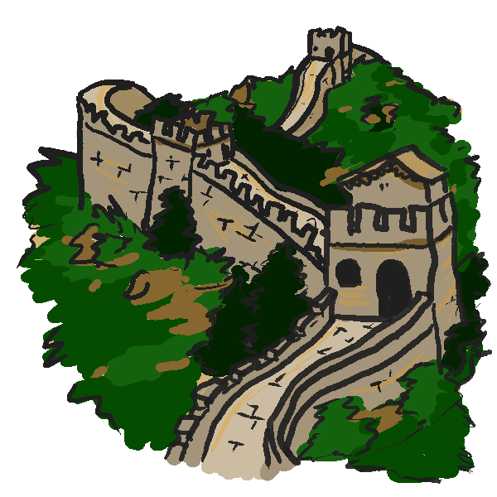

**China**

7 weeks

**History –**

Shang Dynasty

* Chronological time line of the main period
* Investigating different artefacts from the Area (how do we learn about the past)
* Role of the dynasties in Ancient China
* Who was Lady Fu Hao and why was she unusual?
* The Hierarchy of society
* Shang Di - The Supreme god –worship
* Dragon bones
* Shang Di - The Supreme god –worship

The Great Wall of China (NCR) Applied task for talk for writing

Terracotta Army

**Science-**

**Year 6 - Evolution**

**Geography – China**

Map work – Lines of longitude and latitude

To label a modern map of China with the extent of the Shang Dynasty rule.

The population clock - <http://www.worldometers.info/world-population/>

The Yellow River Area - irrigation

Modern day Capital – Why do settlements happen around the rivers in ancient civilisations?

**Art**

Chinese writing

Chinese flower art using pinks

Chinese art on pottery using paper plates

**DT** Chinese cooking and food tasting

Ancient Chinese Instrument making

**Music –**Pentatonic scales music

Visits - NA