Langdon Primary School – Progression in Design and Technology (2019)
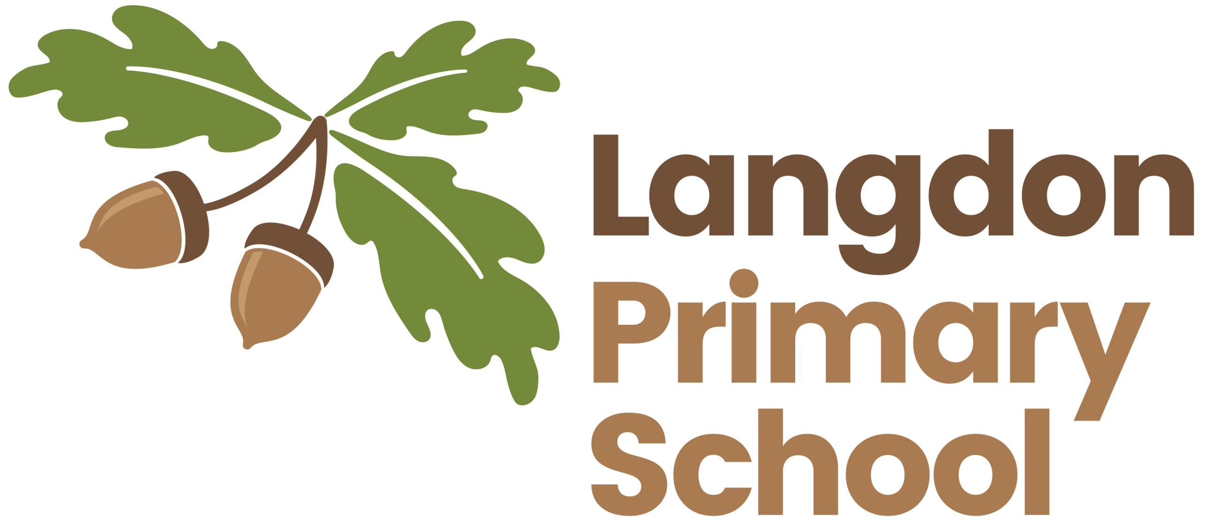
 | Year R | Years 1 and 2 | Years 3 and 4 | Years 5 and 6
Design | - Talk about what they want to make  - Draw what they want to make | - Talk about what they want to make  - Plan and draw what they want to make and for a set task | - Research existing products (eg research existing bridges before designing their own)  - Plan and design a product linked to a set task. | - Research existing products (eg research existing bridges before designing their own)  - Plan and design a product linked to a set task.  - Plan products that are fit for purpose  - Create prototypes
Make | - Experience a range of tools (eg clay tools, scissors, cutlery)  - Experience a range of construction toys and materials (eg Lego, Duplo, bricks) | - Select a range of materials, tools and equipment (eg staples, split pins, hammer, nails)  - Give reasons for their choices | - Select a range of materials, tools and equipment (eg clamping vice, hot glue guns, hand drills)  - Give reasons for their choices | - Select a range of materials, tools and equipment (eg gears, pulleys, wood tools, saws and cutting tools))  - Give reasons for their choices
Evaluate | - Talk about what they have made  - Discuss what works and whether it is as they had expected | - Evaluate their product against their design  - Evaluate their product against the criterion  - Discuss improvements that could be made | - Make judgements about their product  - Identify what is good and say why  - Explain improvements that could be made | - Make links between their product and products in the real world  - Consider the views of others  - Compare to existing designs and products
Technical Knowledge | - To have experience of playing with different materials and techniques (eg sand, water, cutting and sticking)  - To explore and use simple mechanisms (eg levers, sliders, wheels, axles) | - To be able to use and make simple joining techniques  - To be able to use and make simple mechanisms (eg levers, sliders, wheels, axles) | - Knowledge of electrical circuits  - To be able to independently understand and use mechanical gears, levers and pulleys  - To know which tools and materials are suitable for which task | - Knowledge of electrical circuits  - To be able to independently understand and use mechanical gears, levers and pulleys  - To know which tools and materials are suitable for which task  - To understand how to modify complex structures
Cooking and Nutrition | - To play with toy food  - Cut up and eat packed lunches/school dinners  - Sort food- healthy/unhealthy | - Understand where food comes from  - Simple food chains  - Select ingredients and prepare simple meals (eg sandwiches, pizza) | - Show awareness of affordable and seasonal foods  - Understand principles of a varied and healthy diet  - Prepare and cook dishes | - Understand which foods are imported/exported  - Understand where and how a variety of ingredients are grown, reared, caught and processed  - Prepare and cook dishes using different techniques  - Adapt and modify recipes

