Maths **-**

Measure and record the temperature in class regularly and use this data to create a graph or chart

Record the different litter items found during a litter pick in a graph or chart, can this be reduced?

**English (Narrative)**

Creating a biography of Sir David Attenborough

Instruction for living a more sustainable life and how to create eco brick?

Write an informational text about saving energy at home and in school.

Write an instructional text about how to safely conduct a litter pick: ‘Litter-acy.’

Write a balanced argument about whether single-use plastics should be banned.

**PE – Discreet**

**Computing**

**Internet Research –** children use the internet to gather information on space timeline and moon landing

**Our Environment**

January 2019

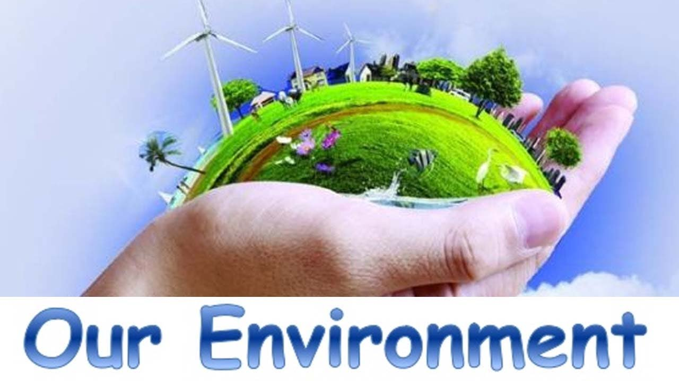

**Geography -** The impact humans have on oceans and how we can change this -NCR

Deforestation – Persuasive letters about the impact to farmers

Where does our food come from? Investigate how developments in transport led to developments in trade and Fairtrade

Where does our energy come from and how does this impact on the planet?

Renewable and non- renewable energy.

Natural resources – how can we conserve?

**History –** looking at settlements for 500 years ago and their needs

**Science**

Construct a marine food chain identifying producers, predators and prey and talk about the impact plastic

Investigate the different states of matter in relation to global warming.

**Art**

**DT–create Jelly fish creatures out of single-use plastics, highlighting the dangers facing animals who mistake them as food**

**Music - Ukele EN**

**Trips**