

**September 2018**

**Dover Class Newsletter**

Welcome back, I hope you have had an enjoyable break. I am thoroughly looking forward to teaching your children and look forward to seeing them make progress in their learning. If yourself or your child are having any worries or difficulties with anything at school or home please come and talk to myself, Mrs Capell or Mrs Harris.

Some children tend to give up on challenging tasks easily, or avoid tasks they have failed at before. Some children might believe that being ‘good’ at a particular activity is something they can not control; we call this a **‘fixed mindset’**. Throughout the year we are going to focus on developing a **‘growth mindset’** where children bounce back quickly from failure and be more likely to explore how they can get better at something. Developing a ‘growth mindset’ can help make children more **resilient** for life.

**Literacy**

In Literacy we will use our topic of Dover castle to write a non-chronological report about Dover castle. We will also be writing some persuasive leaflets to persuade you to visit Dover castle.

Although we read regularly with your child in guided reading and daily Sounds-Write sessions, it is important that you encourage your child to read at least three times a week at home. When you read with your child please write a short comment about how your child read or understood the book. The children will receive rewards for reading at home, but the reading record book needs to be signed to count!

**Dates for the diary**

12.09.18- Swimming begins

24.09.18- Meet the teacher parents evening (come and talk to us if you want to know how well your child is settling into the class or if you have any concerns)

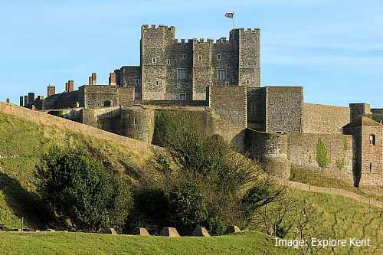

**Dates for the Diary**

19.09.18- Swimming sessions begin

20.09.18- Collaboration dodgeball tournament (Further details to follow)

24.09.18 Meet the teacher evening 3-5pm

**Topic**

All of the classes in the school are named after castles, our class is called Dover castle class therefore, our first topic of the year will be Dover castle.

We will be learning about different types and designs of castles and how they have evolved over time, different features of Dover castle and their uses and focusing on Dover castle during the Second World War.



**Homework**

Homework will be given every Friday and should be returned to school by Wednesday at the latest. Please encourage your child to complete all the homework in their homework book however, if they are struggling please come and see me so I can help. If your child is unable to complete their homework please let me know. Mrs Britton also runs homework club, which is every Monday lunch time, for those who need support.

**PE**

This term our PE days are **Monday** and **Wednesday**. Every Monday the children will have PE with coach Becci where they will develop their skills and stamina in a broad range of physical activities and competitive sports. We will also be going swimming every Wednesday at Dover Sports Centre. Our first swimming session is 19th September so please ensure your child has either a one piece swim suit or swimming trunks above the knee, as well as a towel.

**Mathematics and Mathemagician**

This term in Mathematics the children will be learning the following:

* To read and write in words and numerals, numbers over 1000
* To count backwards through zero into negative numbers
* To round numbers to the nearest 10, 100 or 1000
* Using partitioning (Y3) and written methods (Y4) to add Th H T U
* Use a number line (Y3) and written methods (Y4) to subtract Th H T U

By the end of Year 4 all children across the country are expected to know their times tables up to 12x12. We will be doing Mathemagician to help learn these important facts. The children have to answer 50 questions in just 5 minutes. Their score is doubled to give a percentage. If they receive 90% or more for three consecutive weeks they move onto the next level. Please help your child to learn the times tables relevant to their Mathemagician level.

* Bronze – 2s 5s 10s times tables
* Silver – 2s 3s 4s 5s and 10s
* Gold – 2s 3s 4s 5s 6s 7s 8s 9s 10s 11s and 12s
* Platinum – All of the above, plus the associated division facts and use of decimals