Maths **- Not linked**

**English (Narrative)**

Persuasive brochure based on leads castle

Children then create one based on their own castle invention

Story based on the castle scene from Black Powder

Children switch perspective and write form a first person retelling the story in their own words

**PE –Dance**

Tudor Dance

**a**

**Computing**

**Internet Research –** Programming guard the castles on purple mash- children learning to use the collision detection

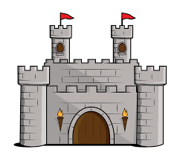

**Castles/Tudors**

7 weeks

November 2018/19

**History**

The Wars of the Roses – Recount of the main events

Chronological time line of the Tudor period. Children order events and choose main events

Henry VIII – and his wives – linked to portraits

Creating 6 sider openers on Henry and his wives

NCR about food during the Tudor period

Learning how life was different for rich and poor

**Geography**

Locating different castle’s counties around the castle

**Science –**

KENT SCHEME – Forces

Making a trebuchet – linked to levers and pulleys

**Art**

Creating 50/50 portraits of famous Tudor Monarchs

**DT Designing** a balloon propelled rocket

**Music - EN – Ukulele**

Visits – Visit Leeds Castle