**English (Narrative)**

Narrative story based on a Tsunami arriving.

Children learn a first person recount and then switch styles to make it into a narrative. To be used Y6 evidence.

Looking at model for NCR on a specific weather phenomenon and then children produce one of their own on a chosen phenomenon.

Discreet Lessons

The Day The Crayons Quit

Innovated into The Day the

Chairs Quit.

**Maths**

Calculating rainfall averages in different parts of the world and producing line graphs

**PE – Invasion games/ Athletics**

**Computing**

Researching different weather phenomenon

Y5 to organise and prepare projects using digital literacy skills

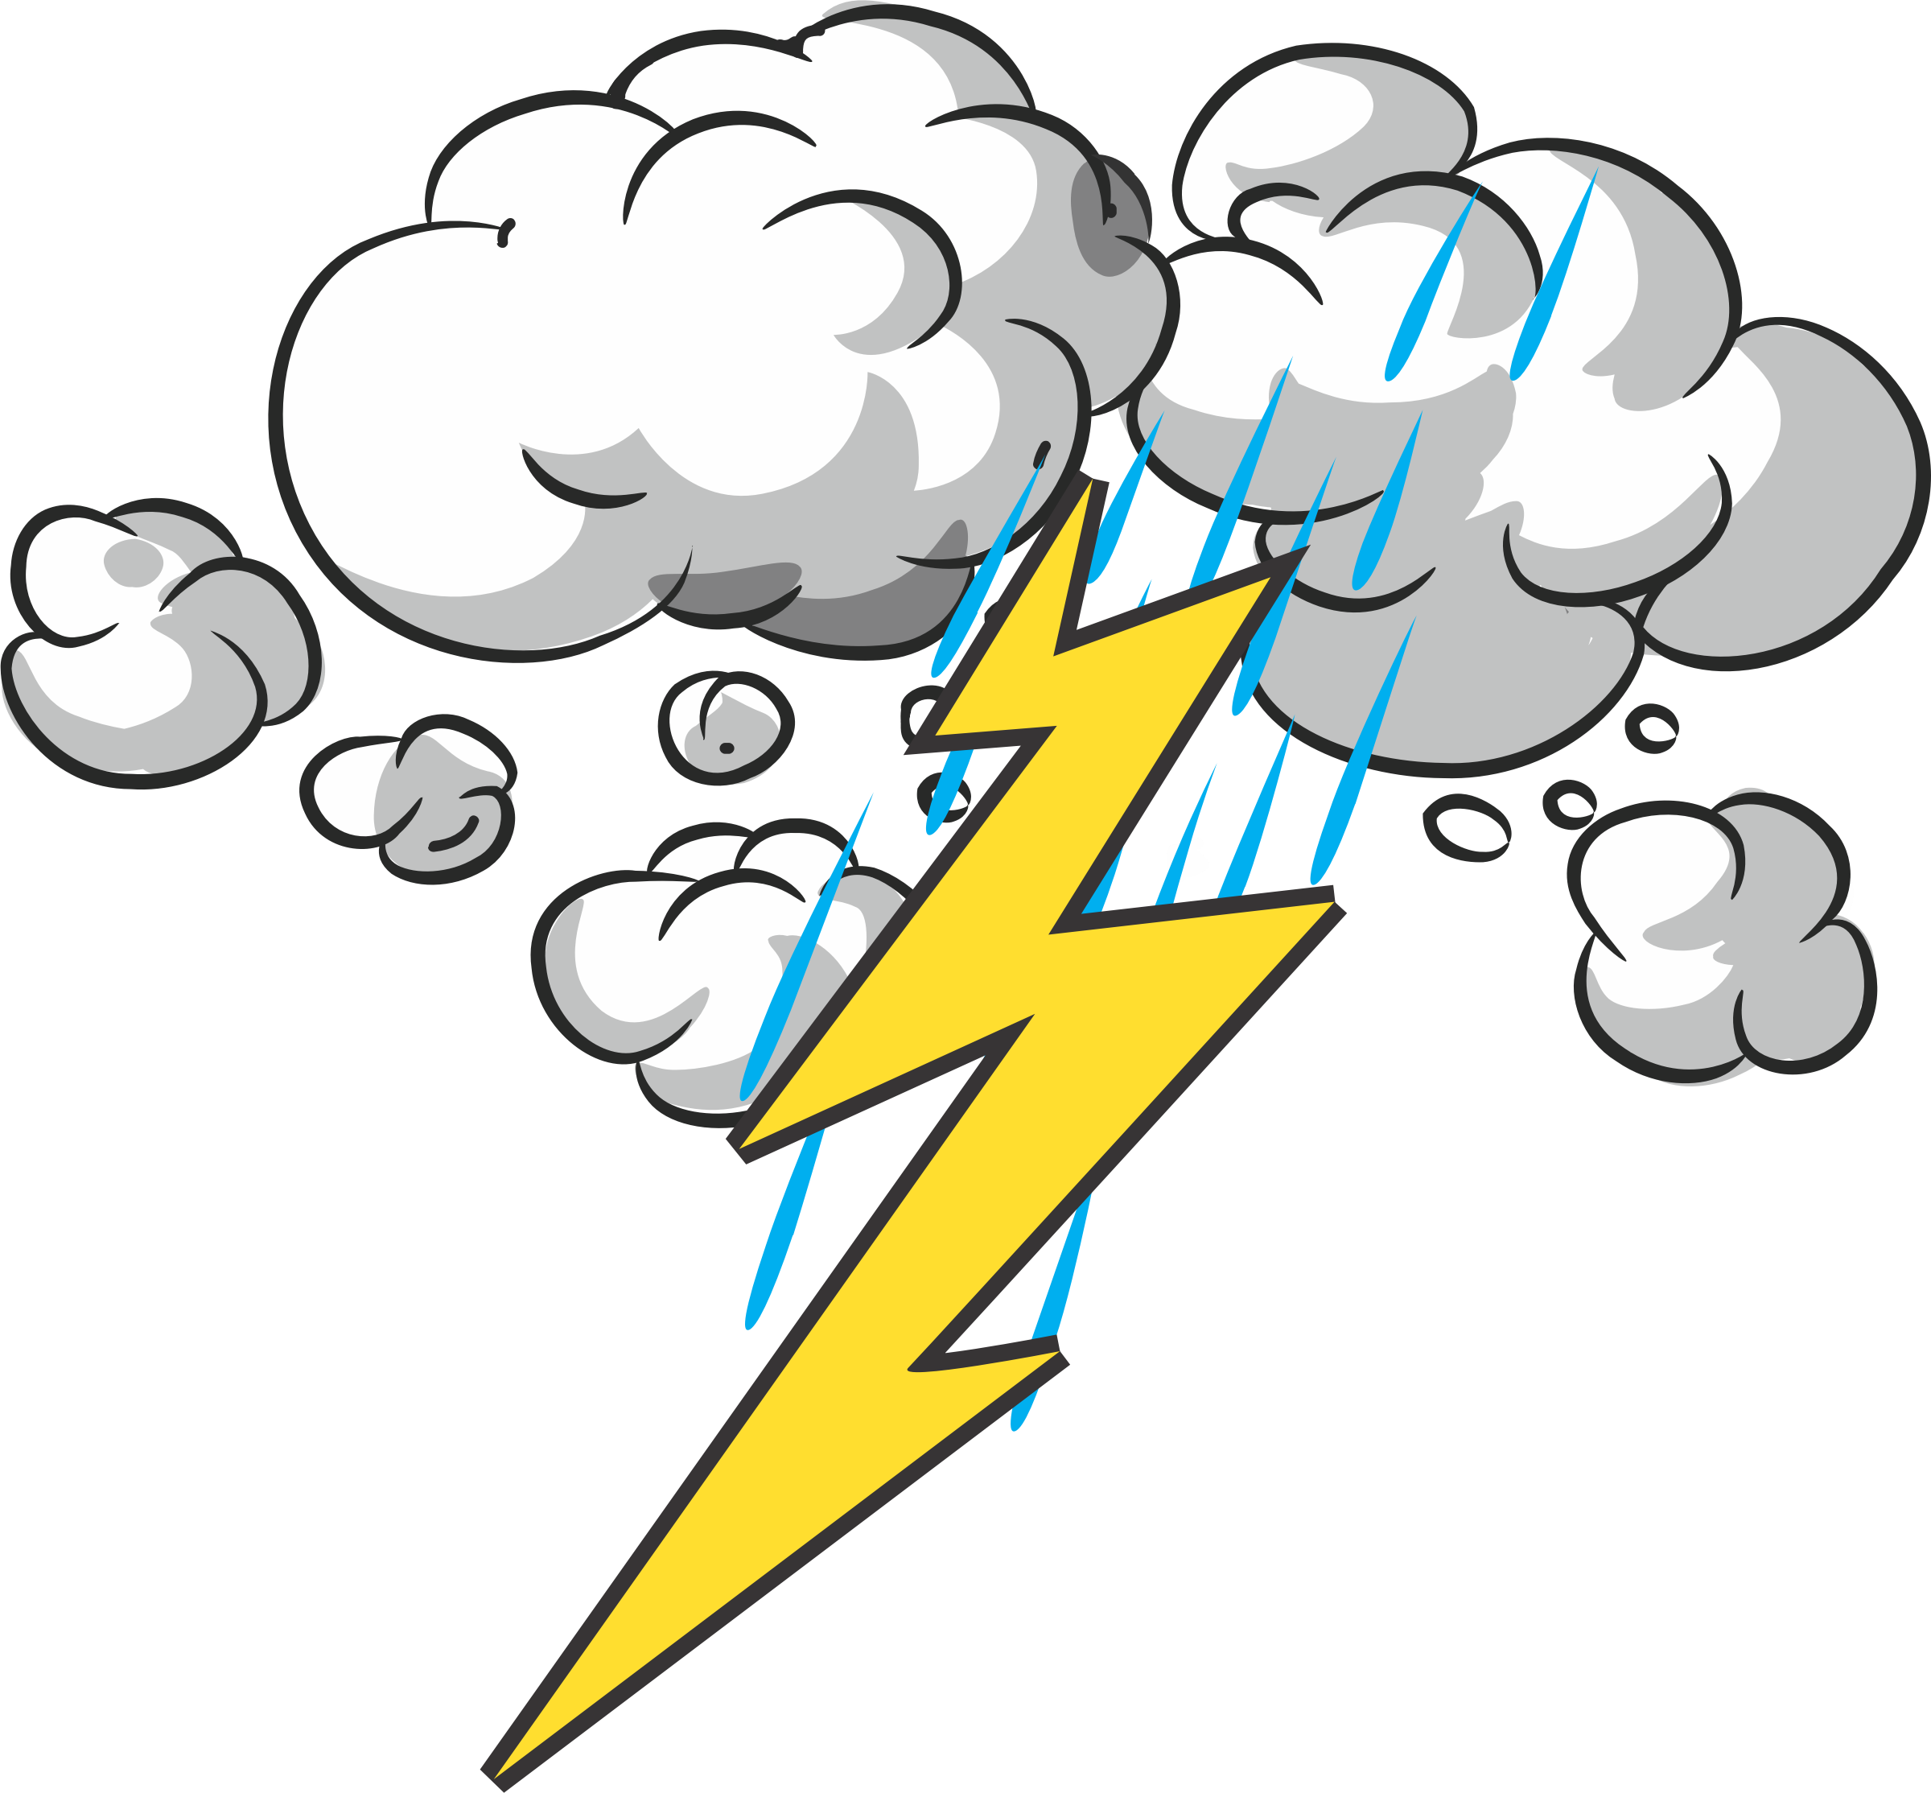

**Wild weather/ raging rivers**

Term 5

**Geography –**

Creating explanations about Tsunamis –

Creating illustrations of the different parts of the water cycles and the different parts of a river.

Creating non chronological reports on the different types of natural disasters

(this will be a continued project for Y5 during Y6 revision sessions)

**Science-**

**Kent Scheme – materials and their properties**

**History –**

**The 1987 Storm – How did that impact on the local environment?**

Children create a script for a news report and think about different people who could give quotes.

**British Values –**

NA

**Music – NA**

Art – recreating the great wave of Kagawa picture

**VISIT –** Following the Dour through Dover.