**Maths –**

**Symmetry- space invader street art picture.**

**Design using squared paper thinking about colours and symmetry before moving to foam to create picture.**

**Computing**

**Spray paint graffiti tag creator**

**ICT to research Banksy and his life story to be used in the writing on non-chron reports**

**Creating 8-bit style in the style of graffiti artist “Space invader” using shadows to make it look 3D – lines purple mash**

**PE –**

Street dance

**English (Narrative)**

**Talk for Writing- NCR –** Who is Banksy? Banksy fact file.

Children then invent their own street artist in a similar style.

**Talk for writing – Discussion Text -** Should we install a graffiti wall in Langdon Park? Ch then create their own

**Newspaper report** about the a Banksy appearing in our school (Afternoon Session**)**

**Instructions -** How to create Banksy style stencil (Afternoon Session)

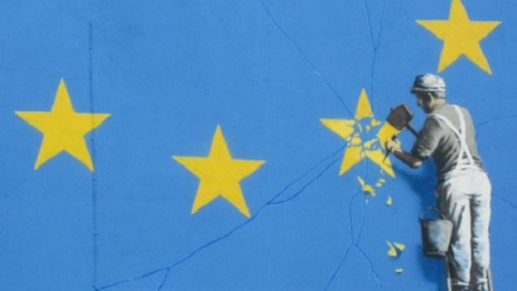

**Banksy**

**Term 1**

**2017-18**

**Science - NA**

**Geography –**

Bristol - What is like? What other places are similar? Is like Langdon? Small Study of the area

Where are Banksy’s work located around he world? Children give names of pieces and cities and towns around the world then use maps and ice to locate the countries and place them on a blank map.

**History –**

The history of Cave drawings and how they tell us about the past

The Clifton Suspension Bridge in Bristol

**Music – NA**

**Art**

Hand drawn graffiti tag using ICT

Create a Banksy style stencil picture of their own initials

Analysis of some Banksy art – What do they think he was trying to say

Visits - NA

**British values**

Is graffiti wrong? Coming up with the Pro’s and Cons of installing a graffiti wall to be used to help write balanced arguments during literacy.