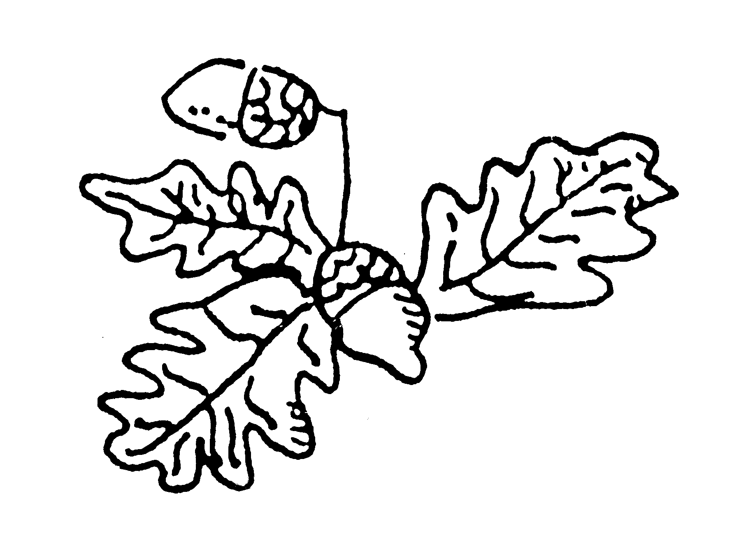Langdon Primary School Planning Book

Long Term Plan: Year 1 and 2 B Term 1 (2017-2018)

Term 1 | Theme/Topic: Ourselves
Predominant subject: Science
Other subjects: Geography, D&T, history
 | Programme of Study | Knowledge | Skills | Understanding | Possible Activities | Local Perspectives | Visits and Visitors
Mathematics
English | Speaking  Reading  Writing  To develop positive attitudes towards, and stamina for, writing.  To write simple sentences from memory.  To sequence sentences to form narratives.  To write for different purposes | Facts about Kandinsky’s life | Features of writing lists and instructions |  | Instructions – how to make body with moving parts  Lists/recipe- friendship  Labelling
Science | To identify, name and draw basic parts of human body.  To know about the senses. | Names of body parts | Observation  labelling |  | Draw and label bodies  Make bodies with moving parts  Sound walk
Art and Design | To use a range of materials creatively to design and make products.  To use painting and sculpture to develop ideas |  | Colour mixing |  | Self portraits
Computing
Design and Technology | To design a product  To use a range of tools and equipment. |  | Generate ideas  Produce a design- communicate through drawings  Cutting, shaping, joining, finishing  Evaluating and improving |  | Make models with moving parts
Geography | To use maps and atlases. |  | Drawing a map  Observational skills |  | Make maps of sound walk
History | To learn about changes within living memory. |  | To sequence events chronologically |  | Draw members of their family
Music | To use their voices expressively and creatively by singing songs | Words to songs |  |  | The body song  Heads, shoulders, Knees and Toes
Physical Education

